Absalom, Absalom! in Four Dimensions: Characters, Locations, Events, and Language
Johannes Burgers

Introduction
Absalom, Absalom! is not a likeable text. Its structure is overwrought, its characters are inscrutable, and the prose is nearly impenetrable. There is also no shortage of digressions – parenthetical, italicized, and otherwise – that force even the most forensic reader to return and re-read that which has transpired only a few lines earlier. Early on, in what could serve as a description of the narrative writ large, Mr.Compson refers to the dramatis personae of the Sutpen tragedy as a recovered and barely legible chemical formula that appears to be inert. When you bring all the characters together “nothing happens,” and so you “re-read, tedious and intent, poring, making sure that you have forgotten nothing, made no miscalculation; you bring them together again and again nothing happens” (80). This sensation of mixing a formula that produces no reaction might feel familiar to some first-time readers. Perhaps the formula feels inert because the science is all wrong. The novel is, if anything, alchemical. Its power comes from its gnostic devotion to the why, which overshadows the more mundane matter of the what.
Like Sutpen’s own divaricated progenerations, the text’s difficulty has engendered multiple branches of critical interpretation. Although divergent in their aims and illuminating in their own ways, they are unified in their approach. Each relies on a methodology that builds evidence for a particular interpretation through a close-reading, supported by varying degrees of biographical, cultural, and historical context. As an alternative and complement to this approach, this essay deploys a methodology broadly described through the catch-all term: digital humanities. Generically speaking, digital humanities scholars leverage the computational power of digital technologies to perform analyses that would be very difficult to do using traditional humanities methods. In this vein, the work here draws on the database and digital tools available through Digital Yoknapatawpha (DY). Hosted by the University of Virginia, DY is a resource for students and scholars of William Faulkner. The team has encoded all of the characters, locations, and events in Faulkner’s Yoknapatawpha fictions. Through the site, users can study “deep atlases” of each text, explore archival material, listen to audio recordings of Faulkner, perform powerful relational searches, and analyze the texts using advanced data visualizations.
Using DY and its rich data sets, it is possible to investigate Absalom, Absalom! from multiple perspectives simultaneously. While it might be tempting to use the database to get to know the “facts” about the Sutpen family history, such an approach glosses over the highly interpretive nature of textual encoding, and, more to the point, contradicts Absalom, Absalom!’s ambivalence about ever truly knowing a story. Instead, a more productive approach is to use the database to showcase the multiplicity of interpretations the text offers. In this spirit, this essay has not been organized around a central thesis that makes a definitive claim about Absalom, Absalom!; instead it consists of four loosely connected vignettes structured around different data visualizations. The visualizations have been modified for the purposes of print; the full interactive versions are available online as a supplement. Each mini-essay covers a separate facet of the novel: characters, locations, events, and language. While each vignette could, arguably, be read separately, the themes echo each other: characters and race, locations and slavery capitalism, events and history, language and the past. These themes are still as resonant today as they were in 1936. Indeed, current conversations about the racial legacy of America’s past are as much about history’s refusal to stay silent, as they are about finding the language to speak about that legacy in the present. Absalom, Absalom! suggests that those discussions do not end, but are, in fact, an end in and of themselves.

Part 1: Characters

“money, a house, a plantation, slaves, a family — incidentally of course, a wife”
A well-worn quip about Absalom, Absalom! is that it is not a whodunit, but rather a why-done-it. Within the first several pages, the basic facts of the case are laid out: A stranger, Thomas Sutpen, appears in Jefferson one day, builds a plantation, and marries Ellen Coldfield. They have two children: Judith and Henry. Later, Henry’s close friend, Charles Bon, wants to marry Judith, but on the day of their wedding, Henry shoots him and disappears. His daughter unwed, his son gone, and no heir to his estate, Sutpen slides into dissolution. Quentin Compson, the novel’s main detective of sorts, will spend the remainder of the narrative trying to understand why Henry shot Bon by working through the various possible motivations in his conversations with the story’s other narrators: Ellen’s sister Rosa, his father, and his Harvard roommate, Shreve McCannon. No verifiable answer is ever provided, but Quentin avers that Charles was, in fact, Sutpen’s son by a Haitian-born woman with part Black ancestry, Eulalia Bon. The resulting union between Judith and Charles would have constituted incest and “miscegenation” – reproduction between a White and Black person. While there is a universal incest taboo, Quentin speculates that “it’s the miscegenation” Henry “cant bear” (285). In probing the Sutpen family’s sordid history, Quentin exposes the deep contradictions and outright hypocrisy that governed social relationships in the American South from the early nineteenth to the early twentieth century. There was a strict system of formal and informal laws that maintained an inviolable color line between White and Black, but the lives and, indeed, genealogies of White and Black people could be deeply intertwined. In such a society, Charles Bon could be both brother and Other to Judith.
Digital Yoknapatawpha is a particularly powerful tool for investigating these social relationships. Users can pull up the biographies of each individual character, and explore interactive genealogies of each major family, including the Sutpen’s (Massari et al.). Taking the data, it is also possible to aggregate characters by group and create a demography of the world of Absalom, Absalom!. Doing so reveals how racial divisions in the South did not exist outside of social norms surrounding class, gender, and sexuality, but, instead, were constituted through them. Thus, while the text troubles social distinctions based on race, it re-inscribes many traditional assumptions about class, gender, and sexuality.
The demographics of Faulkner’s fictional Yoknapatawpha differ in slight but important ways from that of the actual Lafayette County. In his thorough historical account of northern Mississippi, Don Harrison Doyle shows that the ratio of Black (40%) and White (60%) people in the county was relatively stable throughout Lafayette’s history (303). On the map he drew for Absalom, Absalom!, Faulkner flips this ratio and claims that there are 6,298 Whites and 9,313 “Negroes” (Railton). These proportions are not reflected in his fiction though. There are 3,681 characters, 2,884 (78%) of whom are White. This is significantly more than the 549 (15%) Black characters and the 87 (2%) Native Americans who appear sporadically across the fiction. The demographic makeup suggests that much of the fiction is mostly about White characters. At the same time, Faulkner carves out space for people who complicate these strict racial categories. Characters of mixed Black and White ancestry constitute 1% of Yoknapatawpha’s larger social world and 6% of the population in Absalom, Absalom!. Although certainly small, this number is remarkably consistent with the available census data, even if, as Doyle points out, the number of people recorded as “mulatto” was surely higher because of the “secrecy and denial that surrounded liaisons across racial lines” (148).
Yet, this static picture of the characters is deceptive for several reasons. First, it masks the editorial decisions behind the data. For example, there is no concrete evidence that Charles Bon’s mother was part Black, and it is therefore not self-evident that he should be coded as “Mixed Black White.” At the same time, since so much of the novel revolves around this possibility, this was chosen as more optimal than the other options, “White” or “Black,” which are less accurate, or “Indeterminable” which is not very insightful. Bon is therefore a powerful reminder that every database entry is a matter of textual interpretation.
The raw demographic counts also do not consider how frequently certain characters actually appear in the text. One way to calculate this is using DY’s event data. Each text is split into events, which are defined as one action at one location involving one or more characters. Thus, by adding the number of times a specific character or types of characters appear in events, it is possible to calculate their textual presence. This measure is comparable to how much “stage time” a character might get in a play. The distinction is significant. For example, there is only one Moor character in Othello, but Iago is obviously present on stage quite a bit. The chart below (Figure 1) shows both the raw demographic data and the frequency of character presence by race.
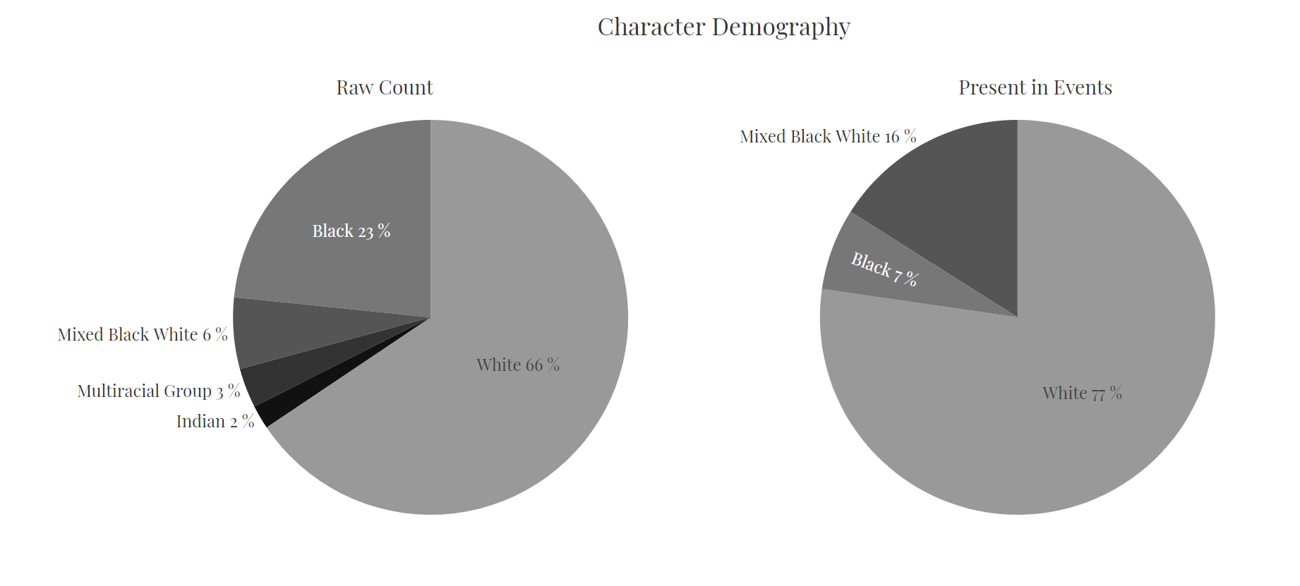
Figure 1: Demography by raw count and by character presence. The image on the left shows what percentage of each type of character is present in the text. The image on the right shows how often they appear.
Several important observations stand out from these charts. First, Native Americans and “Multiracial Groups” do not register because they are present in less than 1% of the text. Second, even though they are a demographic minority, the relative share of mixed ancestry characters increases to 16% when their actual presence is taken into account. The statistics affirm what should be readily apparent from reading the text: characters with mixed ancestry feature prominently. The very existence of such characters represented a threat. As Eric Sundquist explains, “The children of miscegenation not only threatened to blur the distinctions that made slavery possible, but the unions that produced them threatened to distort sexual relations and marriage itself, for black and white alike, into peculiar and tragic forms” (116). What would be harder to detect without a statistical overview is that the attention to mixed ancestry characters does not reduce the focus on White characters, whose relative representation actually increases. Thus, while the text certainly complicates racial binarism, it is far more concerned with how interracial liaisons trouble Whiteness than what they might mean for Blackness.
This is not entirely surprising. With the exception of Charles, all of the main characters are White, and Faulkner uses the central dynamic between Sutpen, Bon, Henry, and Judith to complicate the color line, something other scholars have covered quite extensively (see for example: Carden; Crawford; Davis; Ladd; Snead; Sugimori; Sundquist). Still, only looking at the main characters in a text can be distorting. One of the democratizing features of DY is that it renders minor characters more visible. From this perspective, it becomes apparent that the discussion of race is heavily mediated by gender and sexuality. Charles Bon, as a man with ostensibly? Black blood who wants to marry a White woman, receives as much attention (24%) as all the other mixed ancestry characters combined – Charles Etienne (4%), Clytemnestra (12%), Jim Bond (1%), “octoroon” mistress (2%), Eulalia Bon (5%). This is curious because the text is full of racial transgressions. Eulalia Bon, Sutpen’s first wife, appears infrequently, even though she commits a similar “blood” crime and is ostensibly the cause of his design’s failure. She is merely “unsuitable to [Sutpen’s] purpose and so put aside” (199). Likewise, Charles’s “octoroon mistress” only lives to fulfill his desires. Clytemnestra – the daughter of an enslaved woman who was sexually exploited by Sutpen – has a particularly cruel fate. Despite being Sutpen’s daughter, she is continuously disassociated from the family, and is alternately described as “negro half sister” (87), “wild” (126), “without sex or age” (109), “negress” (139), or, simply, “servant” (149). Of the mixed ancestry women, she is present the most often in the text, but this is only because she has been stripped of all femininity, sexuality, and, indeed, agency. By virtue of their race, Absalom, Absalom!’s mixed ancestry women cannot be loving wives or caring mothers, only useful servants.
Meanwhile, men of mixed ancestry also deviate from the contemporaneous representations of gender and sexuality. The result of a union between two mixed ancestry people, Bon’s son, Charles Etienne is even more feminized than his father, and has “light bones and womanish hands” (162). Contrary to his father’s desire for Judith, he marries a woman disparagingly described as “coal black and ape-like” (166). This leads to violent altercations with those around him as both Black and White men believe him to be White. The relationship is so outrageous to Southern sensibilities that some of the White men who see him with his “charcoal” wife assume he has a “sexual perversion” (167). Conversely, their son, Jim Bond, is a “hulking slack-mouthed” brute (173). He is so hyper-masculine that he is incapable of rational thought, and cannot express any desire at all except unintelligible howling. These various alternative versions of mixed ancestry all suggest that in the minds of the narrators, and perhaps Faulkner as well, racial divergence resulted in deviations from norms surrounding gender and sexuality. It also implies that a deviation in how someone expresses their gender or sexual desire means someone is not truly White. In this sense, the real danger is not that Charles desires Judith, but rather that she desires him.
A further study of the text’s demography shows how race, and in particular Whiteness, is shaped by class. Sutpen is born into very humble circumstances in the mountains of western Virginia. He is unfamiliar with racial difference, and when he was growing up, “the only colored people were Indians and you only looked down at them over your rifle sights” (179). As his family makes its way closer to the plantations of Virginia, it starts to dawn on him that there were differences not only between “white men and black ones,” but also “between white men and white men” (183). He is never able to shake off these vestiges of his backwoods upbringing, and one of the first accusations Rosa levels against him is that “He wasn’t even a gentleman” (9). Even when he is at the zenith of his social status, Mr. Compson points out that Sutpen’s “flowering was a forced blooming” and that he was “playing the scene to an audience” (57). Sutpen’s low breeding forecloses the possibility of him establishing himself permanently among the ranks of the elite families of Yoknapatawpha: Sartoris, De Spain, Compson.
Sutpen’s poor white origins are visible in his social relations. If his descendants are not counted, Sutpen only spends 24% of the text with upper-class characters, the rest of the time he is with Enslaved Blacks (15%), the captive French architect and his middle-class in-laws (21%), and lower-class and “poor whites” (24%). Even when he is with upper-class men, it is always in a grotesque pantomime of class status: fighting the people he enslaved (21), his “grand” wedding to Ellen (43), or the “hunting party” for the French architect. Ultimately, he cannot escape his class. After the Civil War, he reverts to his “poor white” roots and develops a curious bond with Wash Jones. Jones’s shiftless existence in a dilapidated cabin on the purlieus of a grand plantation mirrors that of Sutpen’s father in Tidewater, Virginia in the early 1800s.
Perhaps Sutpen’s “compelling dream” (134) fails because he is not the right type of White. Had he been born into status, there would have been no need to go to Haiti, and he would have married into a bloodline that would have been guaranteed to be “pure” White, because the rest of the surrounding community would affirm that fact. His tragic flaw was to try to become part of a system that only allows entry at birth. The paradox, of course, is that in Northern Mississippi many of the planters who arrived in the 1830s, as Sutpen does, were not “born” into their position; they were hardscrabble men of few scruples who masked their violent rise from indigence through a veneer of gentility (Railey 118–19). Historically speaking, the differences between Sutpen and the plantocracy of the town, is a difference in degree, but not in kind, even if in the world of Yoknapatawpha certain families like Sartoris and Compson are simply better than others, and, in a sense, Whiter. By that same token, there are certain expressions of gender and sexuality that are Whiter than others, and therefore sanctioned. The text complicates the inviolability of some of these distinctions, but the dynamics of the demographic data suggest that the narrators, and perhaps the author as well, are not always able to look beyond the entrenched social categories of their own time.

Part 2: Locations

“the Be Sutpen’s Hundred like the oldentime Be Light”
Sutpen’s rise, fall, and the long shadow he casts, parallel that of slave capitalism. This economic system relied on the ceaseless expropriation of land and the routine torture of a racialized labor force to maximize agricultural production (Baptist 113; Schermerhorn 34). In the American South, the crop of choice was cotton. Though it has traditionally been portrayed as a “peculiar institution” in a backward region, new scholarship has shown that slave capitalism was the commercial engine that shaped the modern transatlantic world (Beckert and Rockman 6). Faulkner’s own “peculiar” history of Sutpen’s rise to power through this system, reveals slavery was neither confined to the carceral space of the plantation or the racial apartheid regime of the South, but extended along global networks of trade. True, Sutpen’s Hundred and its environs are the central locus for a plurality of the action (36%), but just over a third of the events take place outside of the county (35%). One way of representing this narrative spatially is to view the plantation as a key node of a network that stretches across space and time. The resulting constellation underscore how the Plantation cannot be imagined without the slave capitalism system that engendered it.
Narratively, the text slowly expands the reach of the network through the various places the novel travels. Sutpen shows up in town one day and after buying his land, he is suspected of leaving for the Mississippi River to the “steamboats full of gamblers and cotton- and slave dealers to replenish his cache” (26). Quite some time elapses before he leaves the county again, and travels to New Orleans to investigate Bon (82). Shortly afterwards, the war breaks out, and he reaches as far east as Virginia (100). Starting in chapter 7, the narrative travels to Virginia again, when Shreve and Quentin start reconstructing Sutpen’s early years in their monastic Harvard dorm (179). From thereon Sutpen travels to Haiti (193), only to come full circle and return to Yoknapatawpha. Even a fairly crude understanding of geography notes the expanding distances Sutpen’s narrative travels: the Mississippi River ($≈$ 80 mi.), New Orleans ($≈$ 300 mi.), Virginia ($≈$ 750 mi.), Haiti ($≈$ 1550 mi.). The Sutpen family history is ostensibly a local curiosity, but its full story cannot be told without connecting it to a global network of places. This network could equally well stretch to places not directly part of Sutpen’s story but mentioned nonetheless. This includes Harvard ($≈$ 1,000 mi.), Shreve’s birthplace of Edmonton, Alberta ($≈$ 1,700 mi.), the French Architect’s home of Martinique ($≈$ 2,300 mi.), the Haitian Sugar planter owner’s birth country, France ($≈$ 4,500 mi.), and, even back to the “inscrutable dark continent” of Africa (202) ($≈$ 6,000 mi.).
As DY is fundamentally a mapping project, it is possible to take this information and project it onto a digital interpretation of Yoknapatawpha. The custom map below overlays three sets of data: all event locations, locations with a global connection, and locations where Sutpen is present. The primary layer draws a circle around each location proportional to how much time the text spends there. The second layer adds those locations that have a global connection to the text. No events take place in Edmonton, Martinique, France, or West Africa, but the text mentions them. Finally, the location circles have been overlaid with “o-times” symbols ( $⊗$ ) to indicate the locations where Sutpen appears in an event. When the underlying circle and the symbol coincide exactly Sutpen is present at all of the events at that location.
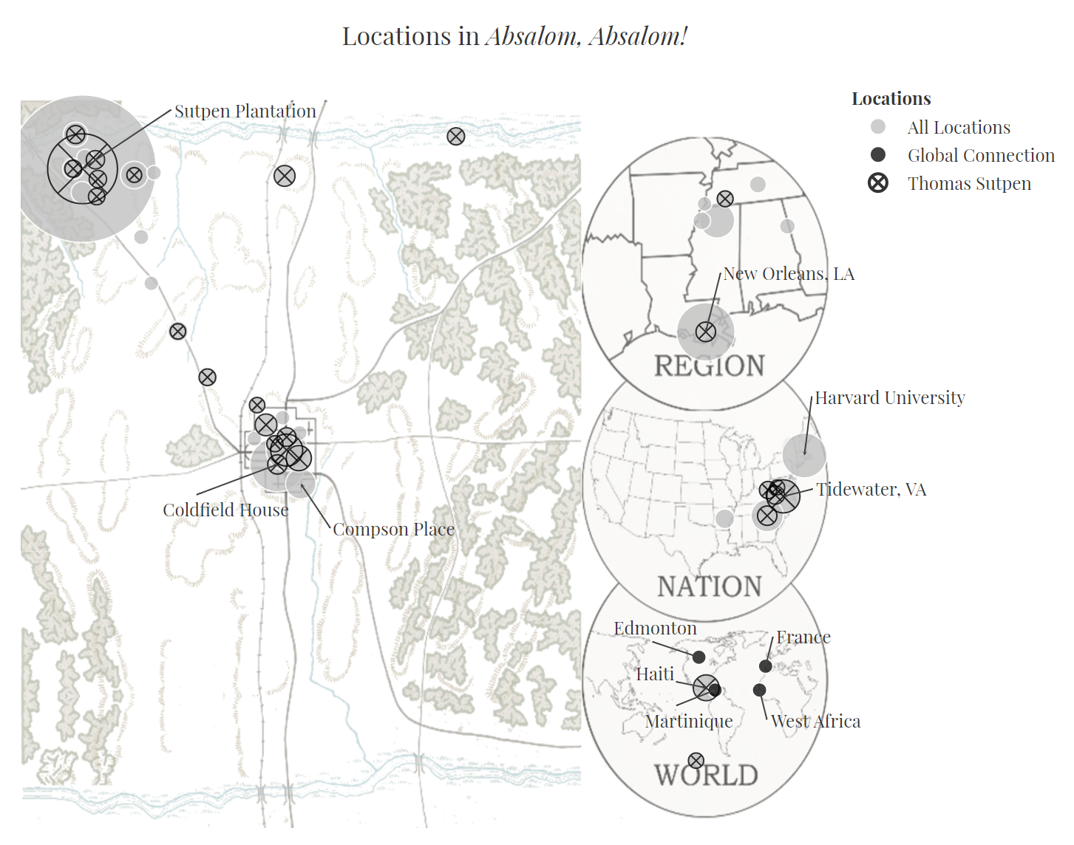
Figure 2: All locations in Absalom, Absalom!. The map underscores the global scale of the novel.
Reading the map from left to right, several features stand out. The Sutpen Plantation is the most prominent location, and, in fact, many of the smaller circles in its immediate vicinity are places on the vast property. Within the county, most of the locations are confined to the areas between the plantation and the town, with a smattering of events in the direct north of the county when Sutpen is searching for the French Architect. Taking a broader view, the action travels to quite a number of places outside of Yoknapatawpha, notably New Orleans, Tidewater, the South during the Civil War, and Haiti. Sutpen is ubiquitous across these locations and there are few places where he is the most present character in an event, or indeed, the only present character in an event.
Beyond these locations, the global connections enmesh the text in the larger transatlantic circuit. The extensive distances between these locations suggests that slave capitalism is not only maintained through intimate social relations, but also reticulated across a network of interlocking spaces. The various characters use these spaces to continuously displace the evils of slavery onto a place “somewhere else,” thereby keeping their own moral complicity at a distance. Rosa places the enslavement in Yoknapatawpha on a continuum with an “old quiet country like Virginia or Carolina,” as if its continued practice were a natural evolution (11). Charles Bon’s relationship with an “octoroon” mistress is possible because New Orleans is a ‘sinful’ place, and the home of a thousand men “without honor or principle” who produced these women and ensnare them into concubinage (91). The town fears that Sutpen’s “wild stock” of African captives who speak with a foreign tongue will mix with their “tame” enslaved peoples (48). Meanwhile, Quentin’s grandfather and, in turn, his father, describe Haiti as, “the halfway point between what we call the jungle and what we call civilization” (202). Rather than Sutpen’s Hundred, the “little island” becomes the true “theatre for violence and injustice” (202). The original sin of slavery is again displaced from the town, and the South more generally. This time onto an Edenic and infernal island in the Caribbean.
The displacement of slavery onto Haiti is striking. Haiti became the first Black republic in the Western Hemisphere in 1804, and thus abolished slavery several years before Sutpen was even born. This historical discrepancy has spawned a substantial critical debate (See for example: Godden; Matthews; Stanchich). Most recently, Wanda Raiford has made the provocative argument that the elision of the historical Haiti and its unqualified acceptance by every listener in the text, also implicates the reader in the erasure of US imperial history and Black agency (103). Extending this logic, Haiti becomes the primordial site onto which to project the evils of slavery. In doing so, General Compson and indeed the entire Compson line, deflect any historical guilt for their own violent subjugation of other human beings. If anything, the “wild” form of slavery in the non-existent version of Haiti, sanctions the “tame” enslavement in the “civilized” US South.
As the constellation of locations suggests, slavery capitalism does not stop neatly at the Mason-Dixon line, and also undergirds Quentin’s attendance at Harvard. Despite its role in the abolitionist movement, Harvard directly and indirectly profited from slavery (Beckert et al. 226). Moreover, Quentin is following in the footsteps of other sons of slave owners and, later, former slave owners who went to Harvard or other elite Northern institutions to be conferred a degree and respectability (238). Though not explicitly stated in Absalom, Absalom!, in The Sound and the Fury it is clear that the tract of land Quentin’s father sells to send his son to school belonged to the Compson plantation. The residual wealth from a system of subjugation that officially ended fifty years previous still helps pay for his tuition.
Only Shreve appears untouched. As a Canadian outsider and someone unfamiliar with the South, he has no historical link with slavery. Yet, he and Quentin are still connected by the same River, the “Continental Trough” and “geologic umbilical” that runs from Mississippi to Edmonton (208). The waterways that bring together the two Harvard classmen were also used to ferry enslaved people, the commodities they produced, and the ideas that perpetuated these social relations. Shreve has inherited the slave capital’s perverse racial logic through these various arteries. While Quentin is famously ambivalent about his relationship with the South and its troubled past, Shreve’s vision of the region and the future it portends is one of white racial suicide. He prophesies that “the Jim Bonds are going to conquer the western hemisphere” and fears that in “a few thousand years, I who regard you will also have sprung from the loins of African kings” (302). It is unclear how much of this is Shreve’s trademark flippancy, but even in his glib sermonizing about the fate of the Western world, he reveals profound anxieties over the disappearance of “pure” White people. He claims that the future Jim Bonds might “bleach out” as they reach the poles, but it will “still be Jim Bond” suggesting that Black heritage represents an inferiority beyond skin color (303). Shreve’s own obsessions with race suggests that the legacy of enslavement cannot be told through one individual family, region, or, even country, but is, in fact, the origin story of the Western world itself.

Part 3: Events

“Maybe happen is never once”
One of the most challenging parts of Absalom, Absalom is certainly the narrative structure. Readers familiar with Faulkner’s other works might recognize the experimentation with different perspectives, stream-of-consciousness narration, and the continuous revision of basic plot points that were also features of The Sound and the Fury, As I Lay Dying, and Light in August. In some respects, Absalom, Absalom! represents the culmination of these narrative innovations. At no other point in his career does Faulkner weave these elements together with such complexity. Absalom, Absalom! features multiple narrators whose stories all confluence in stream-of-consciousness narration that, at times, makes them indistinguishable. What is more, the different narrators continuously revise major plot points, and to borrow Mr. Compson’s apt description, drop these “into the telling as you might flick the joker out of a pack of fresh cards without being able to remember later whether you had removed the joker or not” (203). Disentangling the text is therefore equal parts exasperating and exhilarating.
To complicate matters further, the narrative is decidedly non-linear. Only 18% of the events follow a sequential order, the remainder of the plot either jumps forward (49%) or backwards (33%) non-sequentially. These jumps might appear random, but are actually part of a deep structure. Faulkner’s notes for Absalom, Absalom! make it clear that he had a core design he kept elaborating (Blotner 347; Langford 11). Because the text is so confusing, deciphering its structure has been somewhat of a cottage industry (C. Brooks; Egan 201–02; Matlack), but it was not until the assiduous work of Stephen Railton in 2003 that it became possible to visualize its chronology on an interactive timeline. This data formed the foundation for the encoding of Absalom, Absalom! in the DY database, and helped in mapping out a chronology. Using this DY data, it is possible to generate a plot structure chart.
Conceptually, a text can have two different orders: story and plot. The story is the sequence of events as they happened (chronology), and the plot is the order in which they are told (page order). A plot structure chart places story/chronology on the y-axis and plot/page order on the x-axis. Events that happen later chronologically are higher on the y-axis, while events that happen earlier are lower. Meanwhile, events that are told early on are on the beginning of the x-axis whereas that last thing told is all the way at the end. If the story is told in the sequence of events as it occurs, it will rise at a 45$​^{∘}$ slope. Most of Absalom, Absalom! is out of order and deviates from this 45$​^{∘}$ angle. For example, Sutpen’s origins in western Virginia are not revealed until chapter 7. Chronologically this is an early event, but in the plot it is told much later. This point will be low on the y-axis, but about three-fourths of the way across on the x-axis. Generally, when events drop down the y- axis this is a sign of a flashback. Conversely, a jump up is a flashforward. In DY, the narrative structure of every Faulkner text can be accessed through the “Narrative Analysis” dashboard (Burgers, “Narrative Structure Analysis”).
The chart below has been reproduced in greyscale for this essay. It shows the narrative structure of the text, and how that information is conveyed to the reader: narrated through the external narrator, told by one of the characters, or conveyed through one of the other types of narration identified by DY: remembered, hypothesized, or narrated+consciousness. The later three were consolidated into one data series because their number was relatively low. The chart has also been annotated with major plot points.
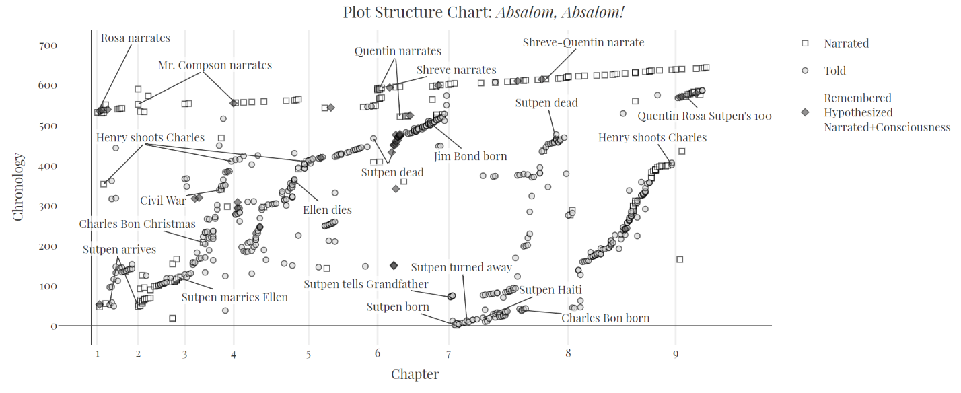
Figure 3: Plot Structure of Absalom, Absalom!. Particularly notable, is the repetition of an S pattern throughout. This indicates a similar structure across the chapters.
At first blush, the above chart can be a bit overwhelming, and it is easiest to break it down into several components. First, the top line of squares that gradually rises from left to right represents the narrative present. These are all the conversations Quentin has with Rosa, his father, and Shreve during the summer of 1909 and winter of 1910. The major stretches of the story told by one narrator are also marked on this top line: Rosa, Mr. Compson, Quentin, Shreve, and, finally, Shreve and Quentin together. Below this top line are all the events that happened in the past. The gray dots that appear to “bubble up” seem frenetic and disorganized, but they actually cluster into elongated “S” curves. The shape of the curve gives an indication of the narrative pacing. Each narrator opens their story with a lot of detail and a high density of events near the end of the S-curve, but there is a tendency to skip through the middle with larger chronological jumps. Some curves start farther down and others end higher up. This difference in clustering makes more sense relative to the chapter markers. Moving from left to right, there is a small S at the bottom of chapter 1, a second one that stretches from chapter 2 to 3, the most substantial one that goes all the way from chapter 4 to the end of chapter 6, and then finally two individual curves in chapter 7 and 8. These patterns suggest the way in which chapters 1 and 2 act as a preview to the story, while chapters 4-6 develop the rising action. Meanwhile, chapters 7 and 8 each in their own way represent a climax as information that was hinted at previously is explained more fully, if still incompletely. Within chapters there is a consistent pattern as well. They open in the present, drop down into the “deep” past, and work their way back up towards the present. There might be some errant events that float between the s-curve and the narrative present, but generally these are previews for events that will happen later. The pattern is actually pretty regular overall. In this sense, all the chapters work together to tell the “entire” story of Sutpen. With a little imagination, one could even slide the curves into each other to make one long curve of the events and put them all in the right order. To help understand what is going on at each point on the chart, certain major events have been annotated. On occasion, some, though certainly not all, repetitions of major events are marked. This is particularly true of Henry shooting Bon, which is alluded to at least four times.
Based on the chart, it also possible to make basic inferences about patterns in the plot, in particular Faulkner’s use of delayed revelation. In the beginning, Sutpen mysteriously appears in chapters 1 and 2, but we do not get his full story until chapter 7, quite some time after it is revealed that he dies at the end of Chapter 5. His cause of death only becomes clear by the end of Chapter 7. The story of Henry shooting Charles is told in the first couple of pages, and again in chapters 4 and 5, but we do not get the fuller version until the end of Chapter 8. The narrative gives glimpses of the past, but only provides their full context much later. To add to the complexity of the history, it is told in multiple different ways through different narrators. Generally, events in the past are “told,” but they can also be narrated by the third person narrator, or use more esoteric forms of narration like hypothesizing or a memory within a telling.
Visually, it is useful to imagine the S-curves as continuous undulations of the past disrupting the placid suspension of the narrative present. The various narrators are not so much plumbing the past, but rather riding its currents to navigate the present, or as Quentin muses:
Maybe nothing ever happens once and is finished. Maybe happen is never once but like ripples maybe on water after the pebble sinks, the ripples moving on, spreading, the pool attached by a narrow umbilical water-cord to the next pool which the first pool feeds, has fed, did feed, let this second pool contain a different temperature of water, a different molecularity of having seen, felt, remembered, reflect in a different tone the infinite unchanging sky, it doesn’t matter: that pebble’s watery echo whose fall it did not even see moves across its surface too at the original ripple-space, to the old ineradicable rhythm…. (210)
Following this metaphor, Sutpen’s arrival is the pebble that ripples through the history of Yoknapatawpha. The narrators each describe the subsequent history in their own way, thereby causing the ripples to undulate and resonate at different frequencies, sometimes negating and sometimes amplifying one another, always disrupting the present. The patterns are all different, but distinguishing where one begins and another ends is impossible.

Part 4: Language

“it struck, word by word, the resonant strings of remembering”
Characters, locations, and events do not exist independently in a text, they are all embedded in language. To state the obvious, authors tell stories with words. Though Absalom, Absalom! is certainly a story, it is as much about the telling as it is about the tale. If Faulkner’s prose can seem impenetrable, it is because it is. Yet, the impenetrability helps the language call attention to itself. To be sure, scholars have pointed out this effect throughout the long genealogy of Faulkner criticism, even if the theoretical idioms in which they do so offer different nuances (P. Brooks 263; Hodgson 103–04; Zoellner 500). Computational analysis amplifies these interpretations by visualizing how Faulkner’s language resists the possibility of telling a story fully.
The most infamous stylistic feature of Absalom, Absalom! is undoubtedly the length of the sentences. In fact, according to the 1983 Guinness Book of World Records it holds the dubious record of the longest sentence in the English language – 1,300 words (McWhirter 228). The claim is absurd. James Joyce’s Ulysses surely has longer sentences, and even Faulkner beat his own “record” quite handily with a 1,600 word sentence in Go Down, Moses (Fargnoli and Golay 102). Faulkner’s long sentences are more than a matter of trivia, however; they quite literally stretch the very concept of the sentence, and by extension the English language. It is a measure of some comfort that they cause trouble for computers and humans alike. Normally, computing sentence length in a text is a very simple procedure. With Absalom, Absalom!, there are so many parenthetical phrases and embedded quotations that it is difficult to detect whether a sentence has ended. This is to say nothing of the far more profound intellectual questions these long pieces of text provoke about the grammatical structure of sentences. There are no hard and fast rules as to how long a sentence can be, and yet at a certain point the structure becomes so complex that it might be syntactically correct but borders on semantic incoherence. Perhaps it is better to say, therefore, that the novel is a collection of clauses occasionally interrupted by punctuation. Given this caveat, the computed average sentence length of 50 words per sentence is at best a rough measure. What is clear though, is that this is significantly longer than other works in English written in the 1930s, which use only about 13 words per sentence (Rudnicka 233). The average masks the sheer number of long sentences: 373 sentences exceed 100 words.
For Faulkner, these long sentences are more than rhetorical pyrotechnics, they try to capture how the past continuously intrudes upon the present. Asked in an interview about why he wrote such long sentences, Faulkner contends that there is no such thing as “was” because everyone brings their past with them. His long sentences are a way to capture this sensation, “a man, a character in a story at any moment of action is not just himself as he is then, he is all that made him, and the long sentence is an attempt to get his past and possibly his future into the instant in which he does something” (Faulkner 84). In a sense, the prose complements the narrative structure, which also sees the past continuously returning.
The typography of a text is rarely remarkable, but here, too, Absalom, Absalom! distinguishes itself. Faulkner uses what can only be considered a life time’s supply of parentheses – 1278 total or 639 pairs. These parenthetical statements are used to elucidate, complicate, contradict, and trouble, the “main narrative.” They are so frequent and lengthy that a full 21% of the text is enframed by parentheses. Faulkner adds a layer of complexity to this by “nesting” parentheses – putting parentheses inside other parentheses. He does this throughout the text, but most intensely in chapter 6, where the majority of the chapter is actually a parenthetical. Both the frequency and the nesting have been represented visually through the figure below.
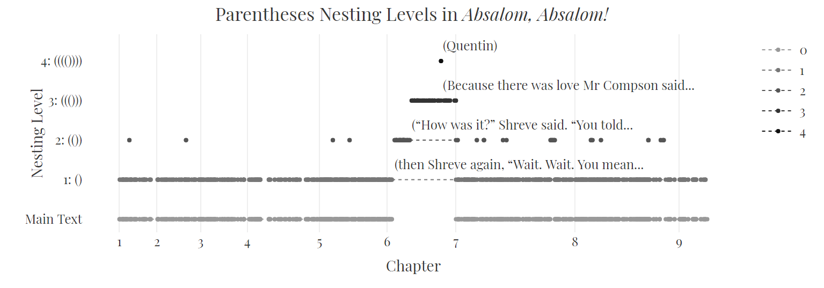
Figure 4: Snapshot of all parentheses in Absalom, Absalom! ordered by their level of nesting.
The figure shows several salient features of the text purely based on its typography. First, at the bottom is the “main text” – the text that is not parenthetical. To some extent this appears indistinguishable from the first nesting level: (). In part, this is simply the consequence of trying to plot too many data points into a small space, but it also demonstrates the ubiquity of parenthetical phrases. With some regularity, this first level nesting is further enframed with second level nesting: (()). The most intense usage of nesting is in chapter 6. In the first couple of pages, the narrative jumps to level one nesting, then second level, and even third ((())), until finally at the apex of the chart, Quentin is nested four levels deep, or more colloquially, he is an aside to an aside to an aside to an aside. It is likely a happy accident that Quentin’s name is the only one that is so deeply nested, it is definitely unreasonable to expect any reader to discover this Easter egg without considerable effort. To be sure, it is possible that Faulkner himself lost track of the parenthesis as the number of parenthesis in this chapter is uneven. Formally, there should be an extra closing parenthesis at the end of chapter 6. Be that as it may, to find Quentin dead-center in the text at the deepest parenthetical level reinforces how much Absalom, Absalom! is as much about his confrontation with the past, as it is about the sordid history of the Sutpens. In many respects that makes him the main character, or as Alex Vernon points out, “Every other voice in the text comes to us through Quentin” (Vernon 164).
Along with Quentin’s deep nesting, the liberal use of parentheticals also speaks to the text’s relationship with storytelling and history. Just as the narrators mix and overlap, so the story constantly branches from the main narrative. These branches continuously draw different information into the story. It is a typographical indicator that no story can ever truly be told one way, but must be told several ways simultaneously.
This sense of simultaneity is reinforced through the text’s repetitiveness. Words, phrases, scenes, and narrators echo one another throughout the text and evoke the sense that one is rereading a particular passage several times (Rio-Jelliffe 76). This effect can be observed in the data about the text as well. For all this apparent lexical originality, statistically speaking, Absalom, Absalom! does not stand out for its word use. There are 8774 unique words, which is actually fewer unique words than expected for a text of its length (Chacoma and Zanette 4; Bernhardsson et al. 14). It is also possible to calculate how many groups of words or phrases repeat over the course of the narrative. Such phrases are called n-grams where n indicates the number of words in the phrase. Thus, an n-gram can be two words: Charles Bon, or it can be much longer. The longest n-gram in the novel is the sixteen-word sentence, “Then I could give you a decent stall in the stable’ and turned and went out.” It is repeated verbatim twice (151, 229). Meanwhile, the four-word phrase, “the two of them” is repeated twenty-nine times.
Counting n-grams is necessarily a crude measure. It does not take into account very minor variations in phrasing. Rosa repeats the phrase “I hold no brief” six times (9, 12, 127, 131, 132), but she states “I hold no more brief” twice (11, 12). Clearly, both are part of the same lexical pattern, but are counted separately due to the slight variation. Nonetheless, it is still possible to quantify the number of directly repeated phrases in the text. Roughly 13% of the texts consists of repeating phrases of four to sixteen words. This number is misleading though, as it follows a more general pattern of n-gram distribution in English language texts (Ha et al. 106).
It is statistically difficult to determine what repetitions are unique to Absalom, Absalom! and what repetitions are simply a function of prose in English. For example, the 4-gram “I don’t hate it,” is repeated four times, and is one of the most identifiable phrases in the book. Meanwhile, the phrase, “in one of the” is repeated seven times, but does not feel particularly unique to the text. It is possible to get a better sense of what role these repetitions play by cross matching them with the characters that appear in the events where they occur. Some characters share common phrases, Charles, Henry, Judith, and Sutpen all appear in events with the phrase “the two of them.” The Sutpen men all share the common n-gram “he would have to.” Meanwhile, characters also have signature repetitions. For obvious reasons, “to the West Indies” is repeated around Sutpen eight times. More tellingly, the most common unique phrase for Charles Bon is “he was up to something,” which is repeated seven times. The sustained accretion of certain lexical cues surrounding specific characters models them throughout the text.
Moreover, the constant repetitions also draw attention to the narrativity of narration. Since signature phrases, scenes, and whole lines of inquiry repeat throughout the text, the meaning of each instance changes with each iteration. The same language is constantly cast in a new light, demonstrating that what is being said cannot be separated from how it is being said. It is the linguistic corollary to the repetitions in the plot structure that continuously ask the reader to reevaluate the grounding assumptions of their knowledge.

Conclusion
The preceding vignettes cover only a fraction of the type of analysis of Absalom, Absalom! that is possible with the DY data. In some sense, this is property inherent to all databases: they make relationships between entities explicit that would otherwise be hard to detect. In another sense, the multiplicity of analyses is also idiosyncratic to Absalom, Absalom!, a text that categorically resists closure and requires constantly new interpretations. Nevertheless, it is possible to draw a large circle around its major themes and show how these cluster together. The characters, locations, events, and language all try to reconcile the South’s racial past with its present only to suggest that this reconciliation is not possible. There will always be a disjunction between that which happened and that which is now happening.
A common way to deal with this disjunction is to talk over it by telling a story, usually one with a happy ending. The storytellings in Absalom, Absalom! underscore that the telling cannot be separated from the tale and the teller. How a narrator speaks of characters is dependent on what character the narrator identifies with, the places spoken about depend on the place spoken from, the understanding of the past depends on the time the present is in, and the language spoken with depends on the listener spoken to. In the end, there is no conclusion to the conversation about race in America, only repetition. The conversation appears to be the point, though. By never allowing the text to truly ever close, Faulkner forces readers to critically re-examine their own relationships with the past, and, in turn, their relationships with themselves. It is only through this examination of the self that an understanding of the other becomes possible.

References
Baptist, Edward E. The Half Has Never Been Told: Slavery and the Making of American Capitalism. Basic Books, 2016.
Beckert, Sven, et al. “Harvard and Slavery: A Short History.” Slavery and the University: Histories and Legacies, edited by Leslie M. Harris et al., Universtiy of Georgia Press, 2019, pp. 224–50.
Beckert, Sven, and Seth Rockman, editors. Slavery’s Capitalism: A New History of American Economic Development. University of Pennsylvania Press, 2016.
Bernhardsson, Sebastian, et al. “The Meta Book and Size-Dependent Properties of Written Language.” New Journal of Physics, vol. 11, no. 12, IOP Publishing, Dec. 2009, p. 123015, doi:10.1088/1367-2630/11/12/123015.
Blotner, Joseph. Faulkner: A Biography. University Press of Mississippi, 2005.
Brooks, Cleanth. “The Narrative Structure of Absalom, Absalom!” The Georgia Review, vol. 29, no. 2, 1975, pp. 366–94.
Brooks, Peter. “Incredulous Narration: Absalom, Absalom!” Comparative Literature, vol. 34, no. 3, 1982, pp. 247–68, doi:10.2307/1770556.
Burgers, Johannes. “Imagining the Continuously Present Past: Visualizing William Faulkner’s Narratives and Digital Yoknapatawpha.” Digital Humanities Quarterly, vol. 015, no. 2, June 2021.
---. “Narrative Structure Analysis.” Digital Yoknapatawpha, http://faulkner.iath.virginia.edu/narrativeanalysis.html.
Carden, Mary Paniccia. “Fatherless Children and Post-Patrilineal Futures in William Faulkner’s Light in August, Absalom, Absalom!, And Go Down, Moses.” The Faulkner Journal, vol. 27, no. 2, Johns Hopkins University Press, 2013, pp. 51–75.
Chacoma, A., and D. H. Zanette. “Heaps’ Law and Heaps Functions in Tagged Texts: Evidences of Their Linguistic Relevance.” Royal Society Open Science, vol. 7, no. 3, Royal Society, p. 200008, doi:10.1098/rsos.200008.

Crawford, Margo. “The Interracial Embodiment of Contradiction in Absalom, Absalom!” Méconnaissance, Race, and the Real in Faulkner’s Fiction. Ed. Michael Zei Etudes Faulknériennes, N° 4 : Méconnaissance : Misrecognition, Race and the Real in Faulkner's Fiction

Etudes Faulknériennes, N° 4 : Méconnaissance : Misrecognition, Race and the Real in Faulkner's Fiction
lin, André Bleikasten, and Nicole Moulinoux. Rennes: PU de Rennes, 2004, pp. 75–88.
Davis, Thadious M. “The Signifying Abstraction: Reading the Negro in Absalom.” William Faulkner’s Absalom, Absalom!: A Casebook, edited by Fred Hobson, Oxford University Press, 2003, pp. 69–106.
Doyle, Don Harrison. Faulkner’s County: The Historical Roots of Yoknapatawpha. University of North Carolina Press, 2001.
Egan, Philip J. “Embedded Story Structures in Absalom, Absalom!” American Literature, vol. 55, no. 2, 1983, pp. 199–214, doi:10.2307/2926281.
Fargnoli, A. Nicholas, and Michael Golay. Critical Companion to William Faulkner. Facts On File, Incorporated, 2009.
Faulkner, William. Faulkner in the University: Class Conferences at the University of Virginia, 1957-1958. Vintage Books, 1965.
Forster, E. M., and Harcourt Brace & Company. Aspects of the Novel. Harcourt Brace & Company, 1927.
Godden, Richard. “Absalom, Absalom!, Haiti and Labor History: Reading Unreadable Revolutions.” ELH, vol. 61, no. 3, 1994, pp. 685–720.
Ha, Le Quan, et al. “Extending Zipf’s Law to n-Grams for Large Corpora.” Artificial Intelligence Review, vol. 32, no. 1, Dec. 2009, pp. 101–13, doi:10.1007/s10462-009-9135-4.
Hodgson, John A. “"Logical Sequence and Continuity": Some Observations on the Typographical and Structural Consistency of Absalom, Absalom!” American Literature, vol. 43, no. 1, 1971, pp. 97–107, doi:10.2307/2924482.
Ladd, Barbara. “"The Direction of the Howling": Nationalism and the Color Line in Absalom, Absalom!” American Literature, vol. 66, no. 3, Duke University Press, 1994, pp. 525–51, doi:10.2307/2927603.
Langford, Gerald. Faulkner’s Revision of Absalom, Absalom!: A Collation of the Manuscript and the Published Book. University of Texas Press, 2015.
Massari, Lauren, et al. “Yoknapatawpha’s First Families.” Digital Yoknapatawpha, http://faulkner.iath.virginia.edu/family/.
Matlack, James H. “The Voices of Time: Narrative Structure in "Absalom, Absalom"!” The Southern Review, vol. 15, no. 2, 1979, p. 333.
Matthews, John T. “Recalling the West Indies: From Yoknapatawpha to Haiti and Back.” American Literary History, vol. 16, no. 2, Oxford University Press, 2004, pp. 238–62.
McWhirter, Norris. Guinness Book of World Records. Bantam Books, 1983.
Raiford, Wanda. “Fantasy and Haiti’s Erasure in William Faulkner’s Absalom, Absalom!” South: A Scholarly Journal, vol. 49, 2016, pp. 101–21.
Railey, Kevin. Natural Aristocracy: History, Ideology, and the Production of William Faulkner. University of Alabama Press, 1999.
Railton, Stephen. “Faulkner Mapping|Mapping Faulkner.” Digital Yoknapatawpha, http://faulkner.iath.virginia.edu/media/resources/DISPLAYS/FaulknerMapsHP.html.
Randel, Fred V. “Parentheses in Faulkner’s Absalom, Absalom!” Style, vol. 5, no. 1, Penn State University Press, 1971, pp. 70–87.
Rio-Jelliffe, R. “"Absalom, Absalom!" As Self-Reflexive Novel.” The Journal of Narrative Technique, vol. 11, no. 2, Department of English Language and Literature, Eastern Michigan University, 1981, pp. 75–90.
Rudnicka, Karolina. “Variation of Sentence Length Across Time and Genre: Influence on Syntactic Usage in English.” Diachronic Corpora, Genre, and Language Change, edited by Richard J. Whitt, John Benjamins Publishing Company, 2018.
Schermerhorn, Calvin. Unrequited Toil: A History of United States Slavery. Cambridge University Press, 2018.
Shklovskiı̆, Viktor. Theory of Prose. Translated by Benjamin Sher, Dalkey Archive Press, 1990.
Snead, James A. Figures of Division: William Faulkner’s Major Novels. Routledge, 2017.
Stanchich, Maritza. “The Hidden Caribbean "Other" in William Faulkner’s "Absalom, Absalom!": An Ideological Ancestry of U.S. Imperialism.” The Mississippi Quarterly, vol. 49, no. 3, Mississippi State University, 1996, pp. 603–17.
Sugimori, Masami. “Racial Mixture, Racial Passing, and White Subjectivity in "Absalom, Absalom!".” Faulkner Journal, vol. 23, no. 2, Faulkner Journal, 2008, pp. 3–21.
Sundquist, Eric J. Faulkner: The House Divided. Johns Hopkins University Press, 1983.
Vernon, Alex. “Narrative Miscegenation: "Absalom, Absalom!" As Naturalist Novel, Auto/Biography, and African-American Oral Story.” Journal of Narrative Theory, vol. 31, no. 2, Department of English Language and Literature, Eastern Michigan University, 2001, pp. 155–79.
Zoellner, Robert H. “Faulkner’s Prose Style in Absalom, Absalom!” American Literature, vol. 30, no. 4, Duke University Press, 1959, pp. 486–502, doi:10.2307/2922824.

All of the data was generated in the R programming language using the tidyverse suite of packages for the calculations and the plotly library for the graphics. The full repository is available at https://github.com/joostburgers/absalom_four_dimensions Due to copyright issues the repository does not include the Absalom, Absalom! text file used for data analysis. The text used was the 2011 Vintage Edition (Faulkner, Absalom, Absalom!), which corresponds with the 1990 edition we used for DY.
The data for this essay is slightly more nuanced than for other texts in DY, because in conjunction with event frequency the event length by word count was also taken into consideration. That being said, there are multiple ways to calculate character “presence” that result in divergent absolute differences between numbers, but their relative share – more, less, least – stays fairly consistent.
Unfortunately, the visualization is no longer operational, but efforts are being made to revive it.
For an extensive and and rather technical overview of this process see: (Burgers, “Imagining the Continuously Present Past”)
This idea was originally developed by the Russian formalists in the 1920s, who labeled story and plot, fabula and syuzhet, respectively (Shklovskiı̆). The distinction between the two elements was also independently intuited by E.M. Forster around the same time (Forster and Harcourt Brace & Company).
This number exceeds that of the “fallible” manual count done by Fred Randel quite a bit. He arrived at 594 pairs, but does not have the benefit computational exactitude (471).
Heaps’ law predicts that that the number of unique words in a text is approximately the square root of the total number of words in a text. $V_{R}(n)=Kn^{β}$ where $V_{R}(n)$ is the number of distinct words in corpus $n$. The special parameters $10<K<100$ and $β≈.5$ vary from corpus to corpus.
It appears that ngrams also follow Zipf’s law. That is, the word frequency of words is proportional to their rank order. Thus, the second most frequent word will be half as frequent as the the first most frequent, the third most frequent will be one third as frequent and so forth.

